New Mexico Educational Assistance Foundation (NMEAF)
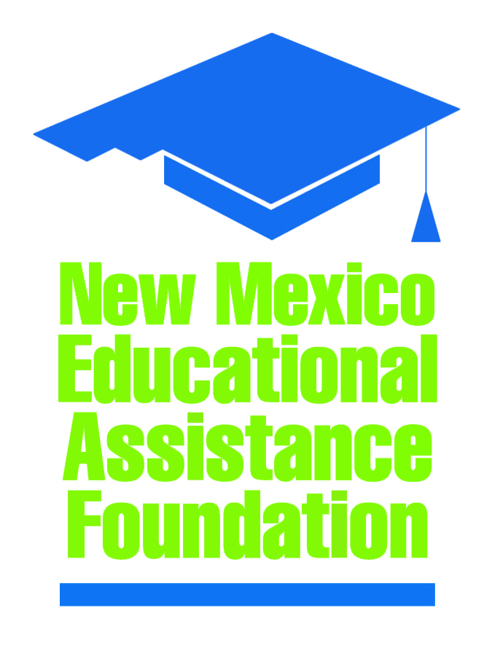
Board of Directors Special Meeting

Location: NMEAF Conference Room/Zoom

When: March 30, 2026
4:00 PM
Agenda

I. | Call to Order – Alex Heubeck
II. | Introduction of Visitors – Brad Allpass
III. | Roll Call – Brad Allpass
IV. | Approval of the Agenda* – Alex Heubeck
V. | Executive Session (for personnel matters)*
VI. | Approval to Negotiate Separation Agreement* - Brad Allpass
VII. | Adjournment*

